The Old Office Furniture Cockpit a Lesson in Recycling
By Ken “Ghost” King
For questions or comments you can e-mail me at kmking@gte.net

Well like all good stories begin, “There I was”. I was searching the Internet one day for my old Marine squadron VMFA-531. When I happened upon the site for the Virtual VMFA-531. I e-mailed them to find out just what they were all about and found myself “flying” with them in no time.

At the time I was flying an old Compaq 533mhz and stock from the box 3D video card. With that I was wondering just what the heck they saw in the online flight experience! For me, to put it bluntly, it stunk! The typical problems with my system, frame rate, communications, the list goes on left me in a conundrum. I had a system that was good for word processing and that was about it.

With that system began my quest to make something that was a functional “cockpit” for my flight simulation experience. It all started with my Logitech joystick. I am more accustomed to having the control stick between my knees not on a desktop. (From my old F4N maintenance experience.) So I fashioned a stand that would fit between my legs in my office chair for my joystick.

Still not pleased with my “engines” performance my search was on for an affordable CPU…. After an exhaustive search, I ended up building it myself. Now I’m “FLYING” with a 1.2gHtZ AMD Athlon with a Gforce2 video card and 312 m of RAM.

Although the Logitech joystick is a good one, it was missing a few things, a separate throttle, and only eight programmable buttons…. Again the search was on! I searched high and low for a durable, easily programmable and use joystick. I tried the Thrustmaster Afterburner, still only eight buttons. I went looking again. I heard to many stories about how difficult the other HOTAS’s were to program etc., and me not being the computer genius I decided on, CH Products Fighterstick USB and Pro Throttle USB. HOLY COW! Now I’ve got OODLES of easily programmable buttons and very functional. Their (CH Products) Product Support, Michael and Nathan, couldn’t ask for a better team! (Luckily I only live 15 minutes from CH Products!)

Ok now I’ve got the separate throttle, where do I put it! The desktop was too crowded! And my joystick stand needed some serious modifications to accommodate the new joystick.

Well my experience with desktop flying was a little lacking in that, I was flying a desk and it felt like it. After visiting a few websites through the Simpits web ring and seeing some of those guys rigs I thought “There’s got to be a way to make a simple, functional cockpit without all the hoopla of the, working AC, G suit and the list of goodies these guys have.” Don’t get me wrong. Those guys have all the goodies that REALLY add to the “flying” experience! I wanted to build a cockpit and apply the KISS method.

The Old Office Furniture Cockpit concept is born! I just happened to have an old office chair that the legs were broken on, hmmmm, EJECTION seat! Remember the old tractor feed printer tables? HA! CPU, monitor, keyboard/mouse stand! AKA, Airframe!

The following are the steps and challenges I faced building the Old Office Furniture Cockpit. Your knowledge of power tools will greatly add to your cockpit building experience.

- As with any project, you need a good foundation! I was somewhat limited by space so the base of my cockpit is 2’X4’X3/4” plywood.
- The base is supported by an I beam “suspension” of 4”X4” pine screwed to the plywood. This all sits on four 2” metal fully articulating casters. For ease of movement.
- The next step is to completely remove the legs from the chair to expose the four mounting lugs on the bottom of the chair.
- With ¾ inch plywood measured to fit the chair boltholes plus 2” in width, drill four holes to accommodate the chair bottom.
- Attach to that ¾ inch piece of plywood a pair of risers (one on left and one on right) made with 2”X8” pine at an angle that is comfortable to you.
- That old tractor feed printer table? Remove the two shelves (one for printer, one for paper) so all you have is the legs. I don’t care what you do with the shelves you won’t need them here.
- Remove the levelers from the bottom of the legs. The lugs that hold the levelers will be used to mount the legs to the base.
- Back to the base, mark the centerline from fore to aft. This is important because all components i.e. seat, airframe… are referenced to this centerline.
- Measure the width of your CPU and add ¼ of an inch. You are going to use this measurement to attach the legs to the base.
- At the forward end of the base attach the legs the measurement you got from the CPU width plus the ¼ inch on the centerline of the base. You’ll do this by drilling holes through the ¾ inch plywood base and bolting to the lugs in the legs.
- Now you are ready to attach the new shelves to the legs. Using ½ inch plywood cut one shelf to accommodate the base of the CPU plus ¼ inch in width and 2” in length.
- Attach the shelf to the lower supports using “plumbers tape” and bolts, nuts, washers at a distance high enough to accommodate rudder pedals to be installed under the CPU.
- Now for the “windscreen”/monitor, keyboard, mouse, shelf. The dimension of this shelf is dependant upon the size of the monitor base and keyboard length/width.
- This shelf is made up of five separate pieces: Monitor Shelf, Keyboard Support, Keyboard Stop (so that the keyboard wont fall off the keyboard support) and Keyboard Support mounting hardware X’s 2. To mount the keyboard support you’ll need to make two pieces of mounting hardware. At one end of the mount you’ll need to angle the mount so that the keyboard will not lay parallel to the floor. This angle is dependant upon your comfort level.
- Time to mount your ejection seat! Basically set your seat (with risers installed) onto the foundation centered and aft so the risers can be screwed into the foundation from underneath.
- Next is the throttle support. The design and manufacture of this will depend largely on the seat you choose as your ejection seat. With the one I chose, it took some imagination and time to figure out, as you’ll see in the pictures.
- Mounting your airframe to the foundation is next. On that same centerline that your seat is on, locate the airframe that you’ve assembled with your CPU and monitor shelves. Mark onto the foundation the location of the leveling lugs so that you can drill holes through the plywood for attaching the airframe. Now bolt onto the foundation the airframe. You are almost done!
- Install the CPU, monitor, keyboard, mouse, joystick, throttle, rudder pedals, and sound system.
- Plug it all into a power supply, and……………. FLY!

See the pictures of my finished cockpit-
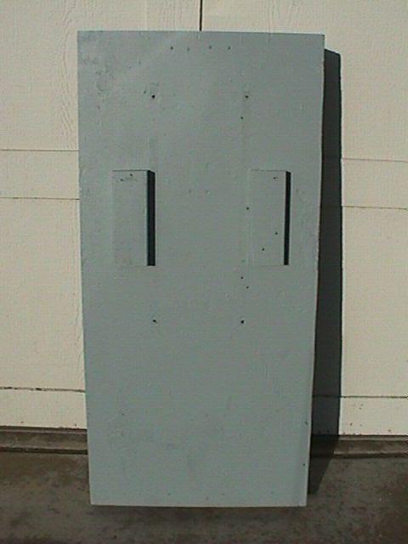
The Foundation

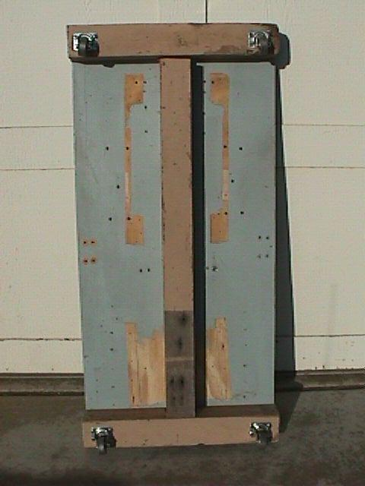
I Beam Suspension With Fully Articulating 2” Metal Casters
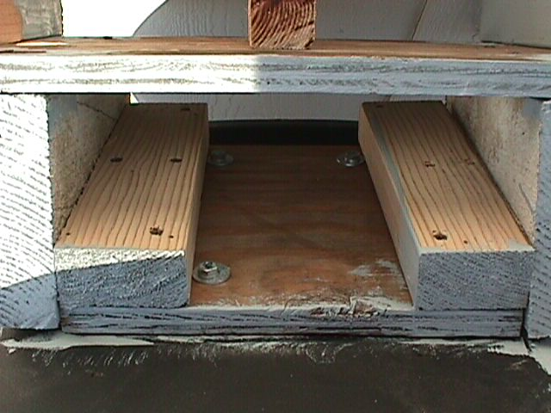
Ejection Seat Installation
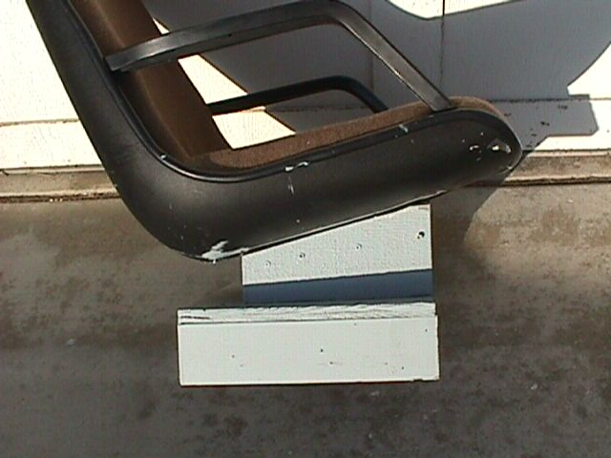
Tilt Your Seat to Fit You
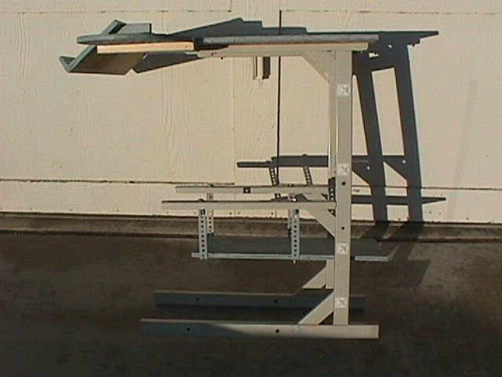
The Airframe
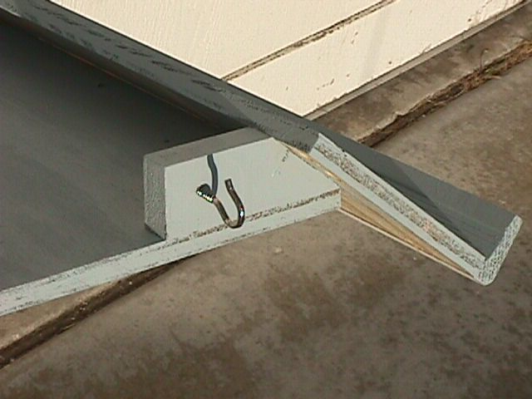
Left Keyboard Support
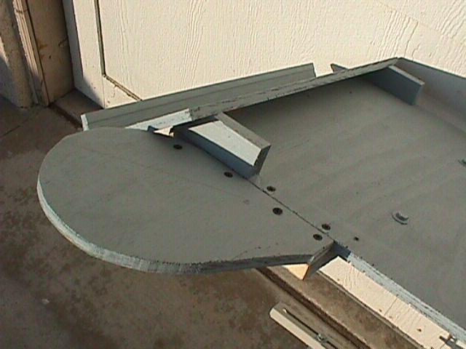
Right Keyboard and Mouse Support
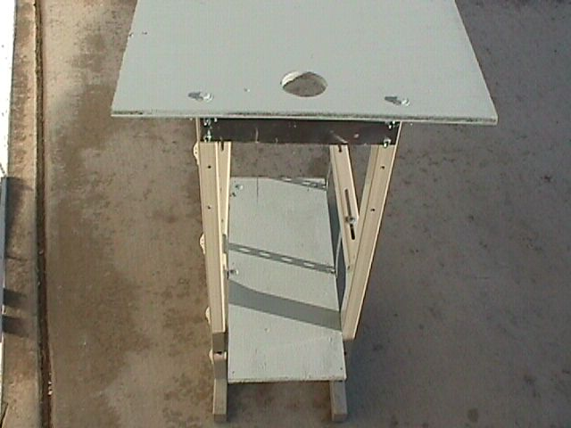
Forward View of the Airframe
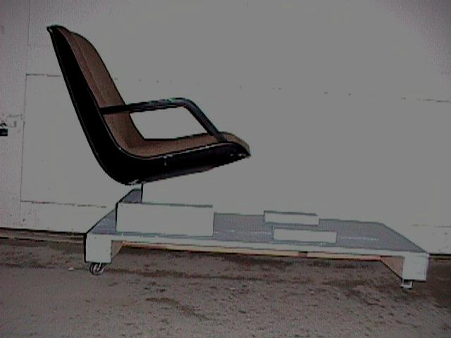
Mounting the Ejection Seat
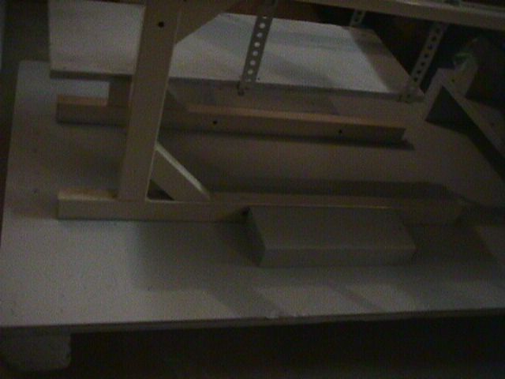
Mounting the Airframe
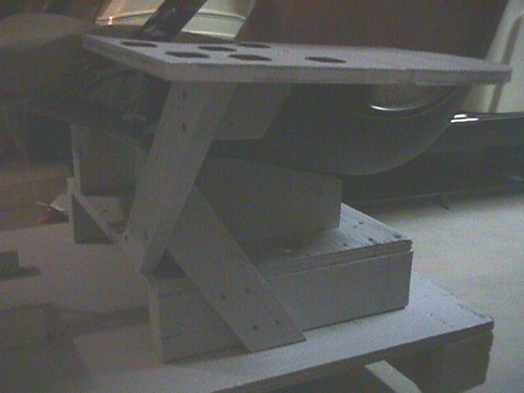
Throttle Support and Cup Holder (Shouldn’t all cockpits have a cup holder?)
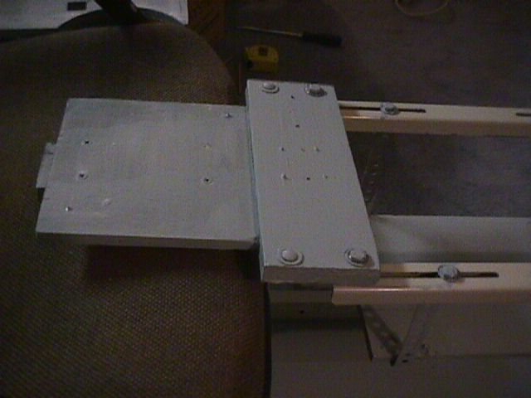
Fighterstick Mount
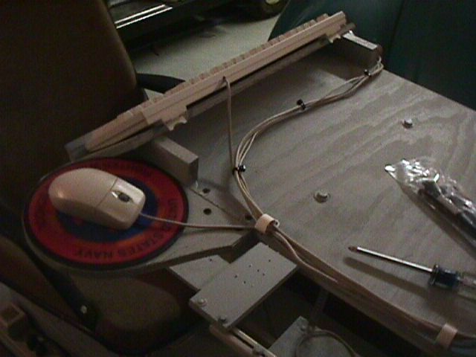
Keyboard, Mouse, Sound Cord Routing
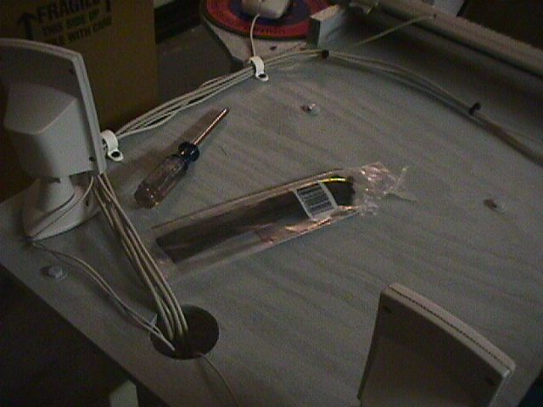
Keyboard, Mouse, Sound Cord Routing
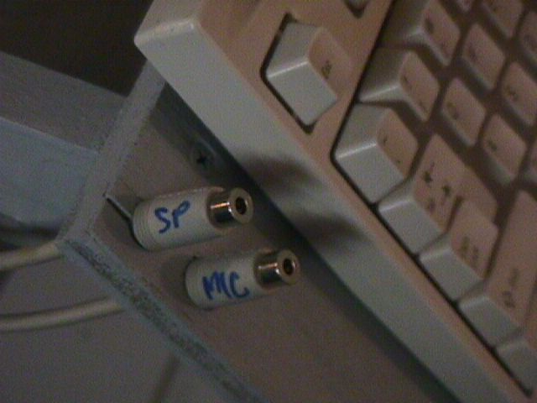
Communications Ports
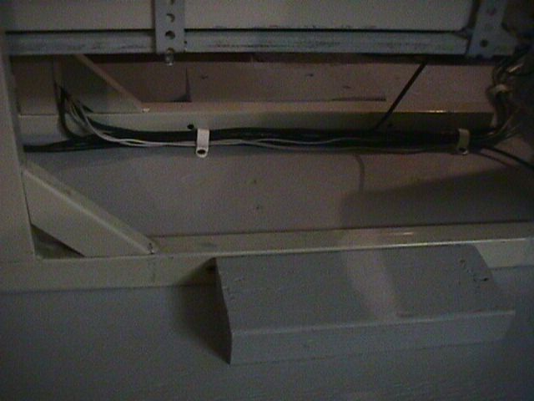
Control Cable Routing
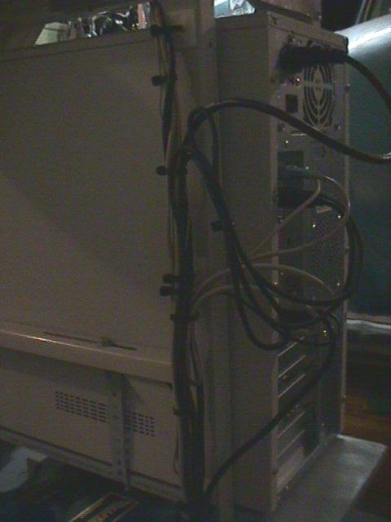
Control Cable Routing
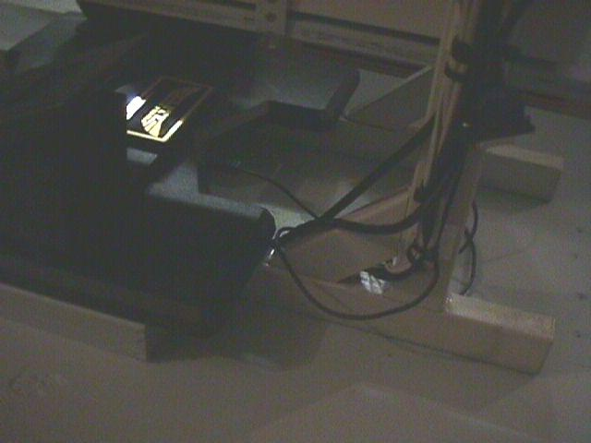
Control Cable Routing
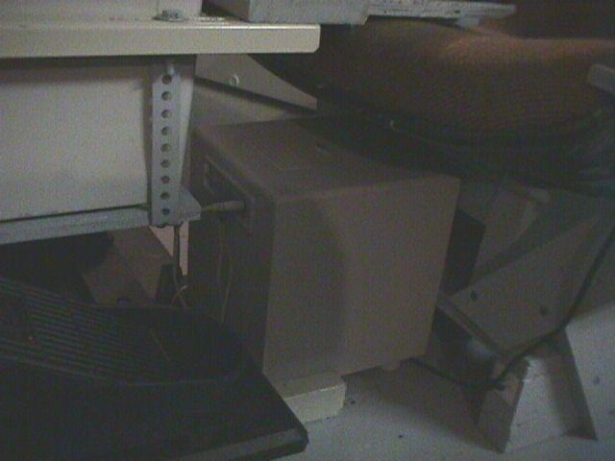
The Woofer Between my Legs
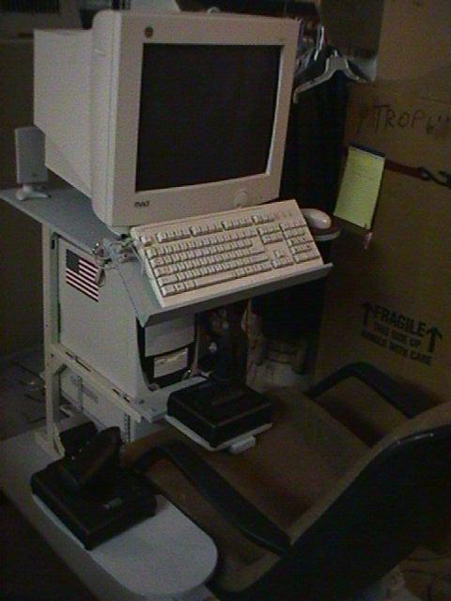
Cockpit Left Side View
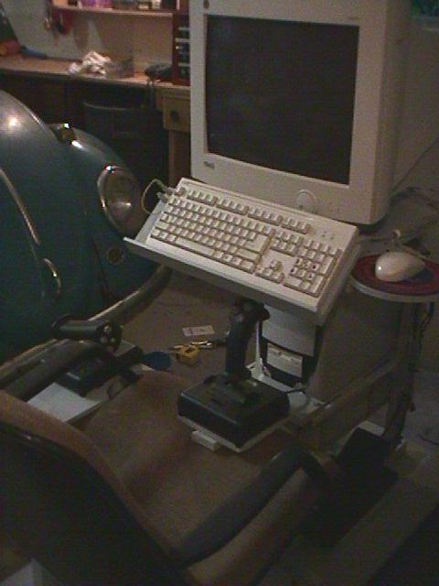
My 1965 VW Beetle (another project waiting to happen)
Cockpit Right Side View
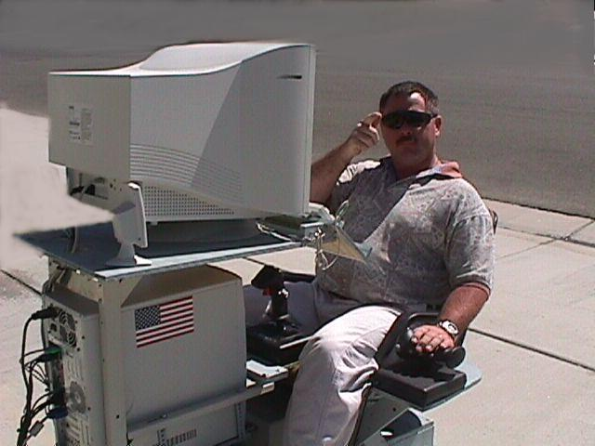

Happy Flying!

